The Open University of Hong Kong

COMPS456F Final Report

Dominion of City: Real Time Strategy Location-based Mobile Game

|  |  |
| --- | --- |
| Supervisor: | Dr. TS Li |
| Team: | dot |
| Member: | WONG Tik San 11181021 |
|  | LEUNG Man Him 11182527 |
|  | TANG Chi Ho 11145882 |
| Programme: | Internet Technology (9717) |
| Date: | 29/5/2017 |

|  |  |
| --- | --- |
| Dominion of City – Location-based Real-Time Strategy Mobile Game –  You are your avatar. Society is the sandbox. | |
| ***dot***  **Wong Tik San, Dixon**  **Leung Man Him, Tim**  **Tang Chi Ho, Toni**  *Supervised by* ***Dr. TS Li*** |  |

|  |  |
| --- | --- |
| Citizens are lacking in motivation to step outside and have a look to their surroundings, Hong Kong people put focus on their own work 6 days a week, and even get stuck into the mobile phone’s screen during the weekend instead of exploring the city.    Our aim is encouraging citizens to explore the city as well as extending their social circle via a community-based game. Hopefully, citizens would enjoy meeting people on the street or having great fun with their friends in order to strengthen the bond of or widen their social circle.  Our approach is a location based game which integrates the reality with a virtual world. The tasks of the game will motivate players to keep jogging in the street because they are required to dominate the generators as much as they.  *Dominion of City* is designed with real world as game element. One of the obstacles would be the incident in reality such as crowd street and road maintenance; however, players can think out of the box to reach their destination, providing high extent of freedom to players.  2 teams compete against each other to dominate generators in a period of time. In addition, the *Bridge* system: forming a line of four generators gains bonus score and end game immediately, designed to set the atmosphere of collaboration, strategy for the competition.  The game is designed for whom are looking for ‘Real Virtuality’. It is believed that *Dominion of City* will spark the motivation of player to explore the community more and establish interpersonal communication. |  |
|  | |

|  |  |
| --- | --- |
|  | *Wong Tik San, Dixon is studying in the Bachelor of Computing with Honours in Internet Technology programme at the Open University of Hong Kong. He is interesting in system development and game design. His short term career goal is being a game developer. He dreams at participating at Artificial Intelligent development in the future. Dixon can be contacted at* [*dixonw1995@gmail.com*](mailto:dixonw1995@gmail.com)*.* |
|  | *Leung Man Him, Tim is studying in the Bachelor of Computing with Honours in Internet Technology programme at the Open University of Hong Kong. Tim is interested in web design and currently running a web site about Japan football as his interest. He planned to achieve his short term career goal of being a web designer after graduating from OUHK. He believes that data is an important tools to analysis many things. He can be contacted at* [*leungmanhim@live.hk*](mailto:leungmanhim@live.hk)*.* |
|  | *Tang Chi Ho, Toni is studying in the Bachelor of Computing with Honours in Internet Technology programme at the Open University of Hong Kong. Idea about software development often comes out from his mind. He is going to have advanced studies integrating advertising with computing and go with this career direction. Toni can be contacted at* [*tangchiho13@gmail.com*](mailto:tangchiho13@gmail.com)*.* |

**Acknowledgement**

We are grateful to out supervisor Dr Li. He always pointed out our mistake and suggest different ways to solve it. He also provided suggestion on suitable development tools and push us when we fall behind the schedule.

Besides, every courses during our university life sharpened our skill for building a project. Those knowledge and course material from professors always help us overcoming difficulty.

We want to thank our peers who are supportive to us. They helped reviewing our project and gave useful advices. When we are under pressure or feeling tired facing academic works, their supportive words charge us up.

Our parents support us for anything anytime is the greatest motivation for us to aim at better outcome. They take care of almost everything at home so that we can focus on learning in university. We are thankful to their contribution in our life.

Contents

[Declaration 6](#_Toc483808055)

[Preamble 6](#_Toc483808056)

[1. Introduction 7](#_Toc483808057)

[1.1 Overview 7](#_Toc483808058)

[1.2 Project Aim 7](#_Toc483808059)

[1.3 Project Objective 8](#_Toc483808060)

[1.4 Updates to the Aim and Objectives 9](#_Toc483808061)

[1.5 Value Proposition 9](#_Toc483808062)

[2. Literature Review 10](#_Toc483808063)

[2.1 Lack of Entertainment 10](#_Toc483808064)

[2.2 Virtual Games as Entertainment and Social Activity 10](#_Toc483808065)

[2.3 Pokemon Go 11](#_Toc483808066)

[2.4 Conclusion 12](#_Toc483808067)

[3. Methodology 13](#_Toc483808068)

[3.1 Overview of solution 13](#_Toc483808069)

[3.2 Description of the Design and Major Features 15](#_Toc483808070)

[**3.2.1** **User Interface** 15](#_Toc483808071)

[**3.2.2** **Information flow** 17](#_Toc483808072)

[**3.2.3** **Modules** 20](#_Toc483808073)

[4. System design and implementation 21](#_Toc483808074)

[**4.1** **The language development technology** 21](#_Toc483808075)

[**4.2** **The dataset** 22](#_Toc483808076)

[5. Key Component 23](#_Toc483808077)

[5.1 Aim of Component 23](#_Toc483808078)

[5.2 LBS (Location-Based Service) 23](#_Toc483808079)

[5.3 Crystal-4 24](#_Toc483808080)

[5.4 DialogMap 25](#_Toc483808081)

[5.5 Chatroom 25](#_Toc483808082)

[5.6 SatelliteHack 26](#_Toc483808083)

[6. Evaluation 27](#_Toc483808084)

[Reference 29](#_Toc483808085)

[Appendix A--Members’ Roles and Responsibilities 31](#_Toc483808086)

[Appendix C1: Team Member’s Final Report 34](#_Toc483808087)

[Appendix C2: Team member’s Final Report 42](#_Toc483808088)

[1. Task and their Status 43](#_Toc483808089)

[Appendix C3: Team Member’s Final Report 48](#_Toc483808090)

# **Declaration**

We(Tang Chi Ho, student id:11145882; Wong Tik San, student id: 11181021; Leung Man Him, 11182527) hereby declare that the project work entitled “Dominion of City” is a record of an original work done by me under the guidance of Dr. Li Tak Sing, and that the content which is not our own has been attributed and referenced properly. There should be no copyrighted content without permission to use. There should be no confidential data.

We declare that the description and information outlined in the individual team member reports are true reflection of the project status to the best of our knowledge.

Signature:

\_\_\_\_\_\_\_\_\_\_\_\_\_\_\_\_\_\_\_\_\_\_\_\_\_\_\_\_\_\_\_\_\_\_\_\_\_\_\_\_\_\_\_\_\_\_\_\_

Date:

\_\_\_\_\_\_\_\_\_\_\_\_\_\_\_\_\_\_\_\_\_\_

# **Preamble**

This project titled “Dominion of City” is commenced by “dot” which is a team of year-4 students under the supervision of Dr. Li Tak Sing. The project was conceived under the inspiration from the current highly rated apps, including “Ingress” and “Pokemon Go”. It is a team battle of point controlling within a short period of time. It is believed to be the catalyst for the citizen exploring the city, and hoped to achieve E-sports level of gaming.

This interim report is written to convey the current progress of the project, to outline what we have changed in the project plan since the last report submitted, and to provide a more comprehensive conceptual framework for the server connection, database and application’s game logic, and to show the way ahead for the remaining parts of the project

1. **Introduction**
2. **Overview**

‘Hong Kong is a city changing rapidly. Constructions ranging from tall buildings, MTR stations to a small store are processing every day’ considered as a fact. However, Hong Kong people put focus on their own work 6 days a week, and even stuck in the mobile phone’s screen during the weekend instead of exploring the city. Indeed, the familiarity is falling behind with the modification.

Besides heavy workload and ‘nomophobic’, the short supply of the current recreation and sports facilities is also a problem, what makes the citizens lacking in motivation to step outside and have a look to their surroundings. That is one of the reasons why people cannot keep up with the community. As a result, citizens would rather tap their finger on the smartphone, which may isolates them even more from family and friends.

1. **Project Aim**

The aim of this project is to provides a community-based game for citizens to explore the city and extend their social circle.

There are some examples that mobile phone game maybe a new method that let people get in touch with community, latest mobile phone game can combine the real world and virtual world by location-based service. They motivate the citizens to walk in the city and enjoy exploring the city.

Furthermore, we would like to let citizens enjoy meeting people on the street or having great fun with their friends in order to strengthen the bond or widen their social circle. The project should emphasize the importance and amusement of communication and cooperation between people.

1. **Project Objective**

To achieve the aim, the main objective of the project is to develop an interesting game that can encourage players visit city and facilitate their social circles.

1. Attracting player to explore community
   1. Implement location based service to the game
   2. Location domination of player
   3. Performing mini game on street which require player to pay attention to the surroundings.
2. Promoting relationship between people
   1. Implement a multiplayer online game
   2. Using Connect-4 as one of the ways to gain marks

Implement location based service to the game can combine the real world and virtual world. So the player want to walk in the virtual world, he or she must walk in the real world first. The domination of location continuing gives motivation to the player to keep jogging in the street. A mini game increases the difficulty in the domination because the game content maybe related to community. Those are the point that attracting player to keep exploring the community more through the game.

Moreover, implementing multiplayer online game increases the chance for players to get in touch with others. Players need to cooperate well to dominate the proper location in order to win the game. In addition, connect 4 is also another way for the player to gain bonus points. It is quite impossible to achieve Connect-4 only by one player. Effective cooperation between teammates and setting strategies should be invoked to achieve the goal!

1. **Updates to the Aim and Objectives**

In game design, we aim at providing more excitement. Therefore, the time limit is proposed and the game is in PVP (player vs. player) mode.

Besides, the mini game for dominating generator should be simple and fast for players to build advantage at the early game, but gradually increased the difficulty in order to help determining the win/lose .

1. **Value Proposition**

Dominion of City is designed for the people who are looking for a mobile game which consists of excitement (battle mode) and fitness (walking or running). The combination of the real world and virtual world sparks the interest of player to explore the community and encourage them to widen their social circle. There is only a few similar games (competitors) among the current game cluster, so it is hoped to be innovative and may create a precedent for the inspiration of ‘really-virtuality’.

1. **Literature Review**
2. **Lack of Entertainment**

One of the problems is lacking in entertainment. Take the recreation and sports facilities under the Leisure and Cultural Services Department as an example, the venues are being speculated in for making personal benefit. The Office of the Ombudsman (2012, 10) points out that Speculation makes the general public more difficult to reserve facilities.

Apart from the inconvenience, the supply of open place for recreation activities is not enough. According to recent research from Civic Exchange (2017), there are less than 3 square meters of recreation space per person in Hong Kong. This ratio is much lower than Tokyo, Shanghai and Singapore for 2 to 3 times. As a result, people lacking in motivation to step outside and have a look to their surroundings.

1. **Virtual Games as Entertainment and Social Activity**

A good virtual game provides fun and excitement with gameplay and game mode. Under a TVT (Team Vs Team) game mode, it is easy to build strong bond between players effectively and efficiently by cooperation and competition.

The main motivations of playing virtual games are the social networking and social satisfaction. According to Teng, Huang and Chen (2015), intensive interaction during gaming form social connection and encourage continuance of gaming. A major need human being, social needs can force gamers to build deep relationship and exchange information to build interdependence, which is the degree of how individuals depend on each other in a relationship (p. 14-16). This is obvious in some games which provide guild function that let players form an organization. Such kinds of community in games assist players to share resources like goods or consultant which is internal social capital (Hsiao & Chiou, 2012, p. 81-82). It causes a higher loyalty to the community and the game. When gaming with strangers or players outside the internal social capital, players still gain positive feeling of mysterious adventure (Snodgrass, Lacy, Dengah & Fagan, 2011, p. 1217) which is instantly enjoyable and they could make new relationships.

Furthermore, games always reward players with scores, experience points, items and so on. Utilizing the reward for advancement, review, sociality, cooperation and competition, players gain satisfaction by flaunting and anticipating next rewards. As a result, they are increasingly willing to learn and spend time on the game (Wang & Sun, 2011, p. 6-9).

Some are afraid that online game may cause addiction harmful to physical and social health but Snodgrass, et al. (2011) argued that playing with real-life-friends can prevent problematic use of games by monitoring and reminding each other. Relationship, pleasure of game and social well-being are positively related (p. 1219).

Wang and Sun (2011) suggested the following:

Physical world activities: Reward systems with support of mobile technology have been used to encourage a range of activities; from shopping, traveling, even to taking exercise. The idea of making players have more physical contact and do something good for health have made more people willing to play or feeling less guilty on playing games; just like Wii has changed the image of game playing. (p. 13)

1. **Pokemon Go**

There are some related existing solutions. Pokemon Go is one of them. In this July, Pokemon Go keeps release in different countries and getting popular in the world. They getting more than 20 million times download in first week. (Cranfrod, 2016) Its trend only keep in a short period, but it shows a new way of game. It use augmented reality technology to combine the reality world and game world. Although it is not an essential function in the game, it attracts people to play it. Pokemon Go also uses the Location Based Service . If player want to move in the game world, he need to move in the real world first. Therefore, if there are some rare pokemon appears, many people will walk or even run to that location. It is success and there are many people walking and catching the pokemon in the street. (Cranfrod, 2016)

Pokemon Go also has social benefits, players will meet together by the street, Pokemon Go gives them a chance to communicate. Some players also expressed that if he does not playing it socially, he would not really play it. (Barker, 2016). So that social communicate maybe also one of the motivation to play mobile games.

1. **Conclusion**

Citizens in Hong Kong are lacking intension to go out to explore the city, but mobile games have the potential to spark their interest and form a habit to move around the city. Current solution Pokemon Go was popular and remarkable with news telling that players are rushing for pokemon around the whole world. However, it is not related to community, player only go out to the street and catching the pokemon. It cannot promote the community to the player. Therefore, a new game that closely related to community is needed. Moreover, the player communication is not an essential element when they are playing the game. As a result, it cannot extend the social circle of player a lot. There should be a mobile game that relates more to city by asking player to walk through the city and pay attention to the surrounding. Besides, the game should let people communicate more by cooperative task and enjoy working together on an aim.

1. **Methodology**
   1. **Overview of solution**

With a view to driving the citizens to go outside more and make new friends, a mobile game should be created. The game, Dominion of City, is to occupy generators (real locations) in the city for victory.

New Age had come when an intern in a TSP accidentally contacted the aliens who have much advanced technology and complicated culture. They developed interplanetary channels to share information, resources and even population. However, there are 2 major kinds of view on the development of the entire universe which form 2 camps. A war was brewing that nobody can stay away from. The intense argument of supporting each party happens everywhere on the Earth. When the war finally happened near Solar System, some people on the Earth tried to support the allies by occupying the energy generator to form the channel but it requires the effort of every one of us. 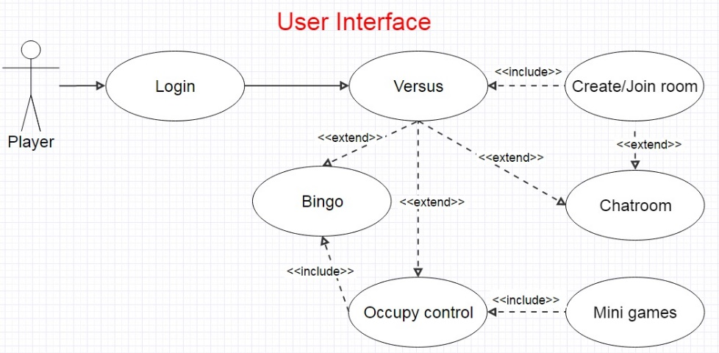

**Use Case Diagram for Dominion of City**

Figure :Use Case Diagram

**Before Gaming**

Players have to register or login an account first. Then, they need to create or join a room shown on the lobby’s game room list. Only if two teams are balanced the game can be started.

**Crystallization and SatelliteHack**

In the beginning of game, 16 well-known landmarks will be randomly assigned into a 4x4 crystal puzzle (Crystal Four). The player needs to approach the buildings and dominate them by playing SatelliteHack, a mini game that players adjust their camera's angle up to the sky and searching for the GPS location of real satellites within the limited time.

Points will be given to the team for owning crystals. If one of the teams forms a bridge (four in a line on Crystal Four), bonus points will be given and the game is ended. Also, times up will end the game. The team with higher score will win the game.

* 1. **Description of the Design and Major Features**
     1. **User Interface**

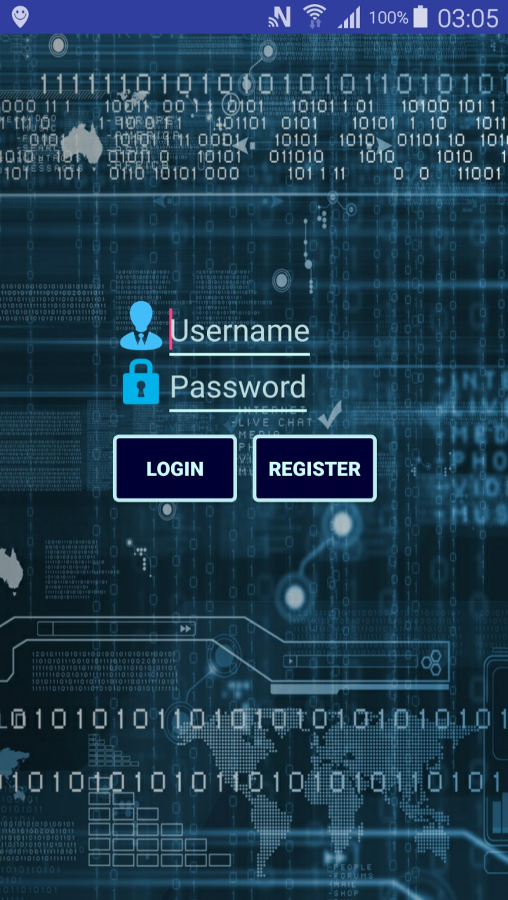The main activity of application is used for login and registration. When the application starts, it will provide two fields for user to type user name and password. There is a login button to perform login and register button to open a new activity for user to register new account.

Figure Login

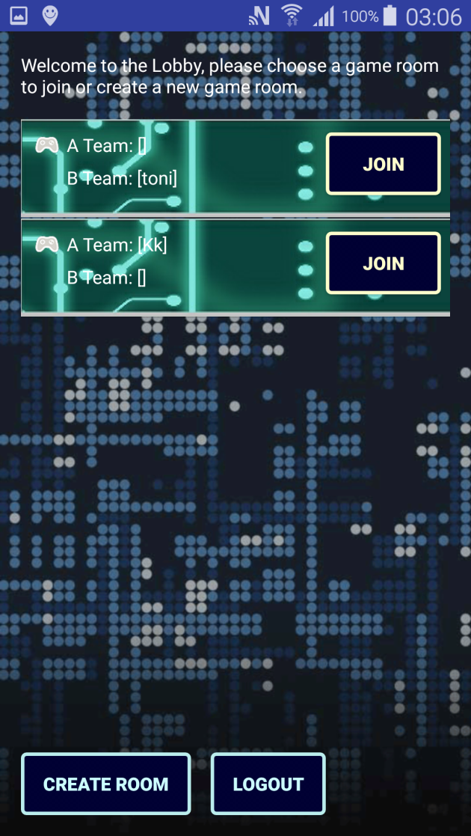Inside the Lobby interface, it has a room list that a user can join, which is showing by a table layout. At the bottom of Lobby interface will also showing a button for user to open a new game room.

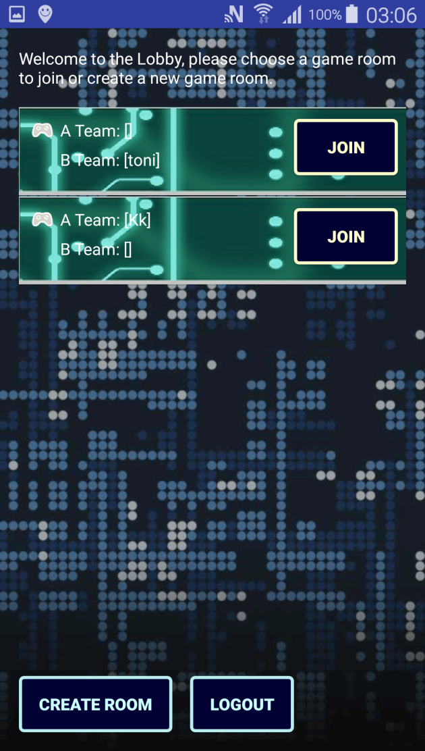

Figure Lobby

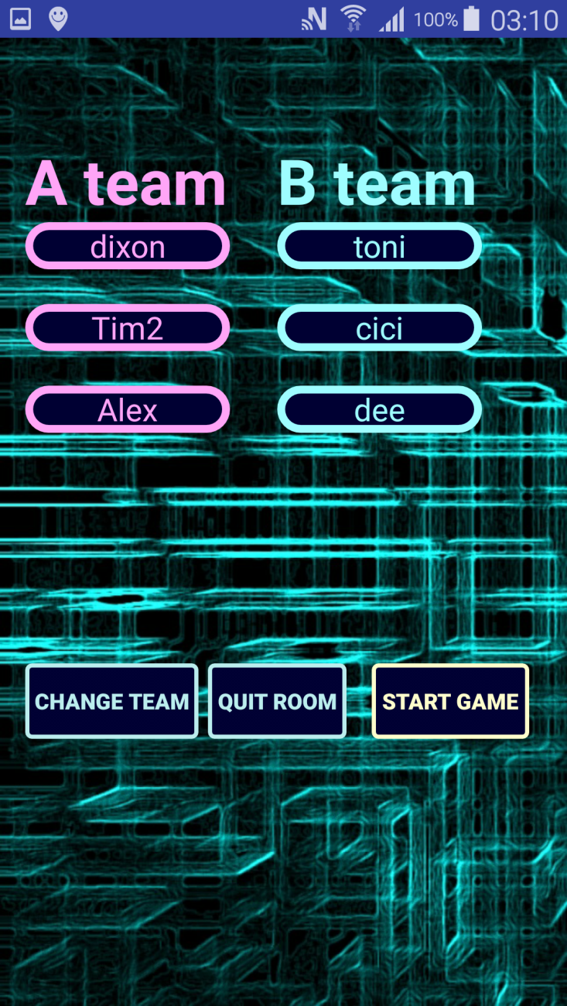

In game room activity, it will update the player’s name when the player joins in. Players’ name will be listed into two columns by team.

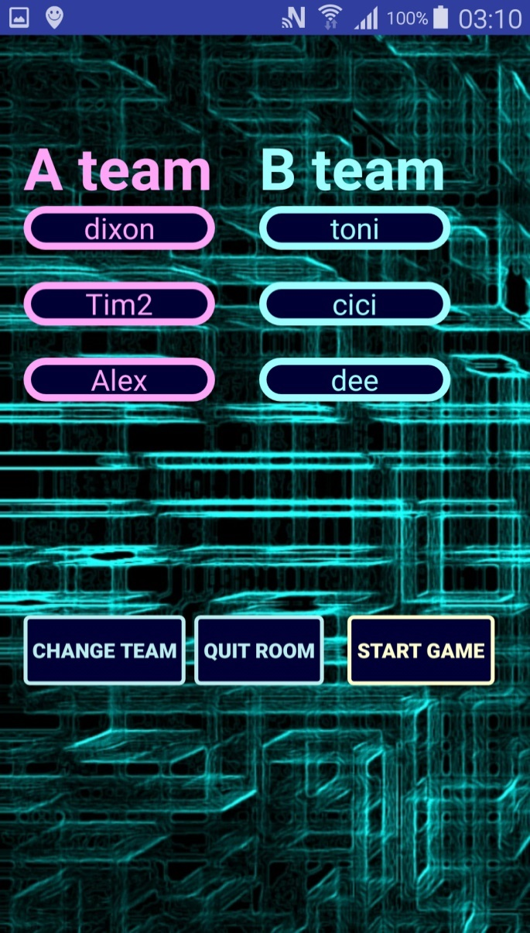

Figure Room

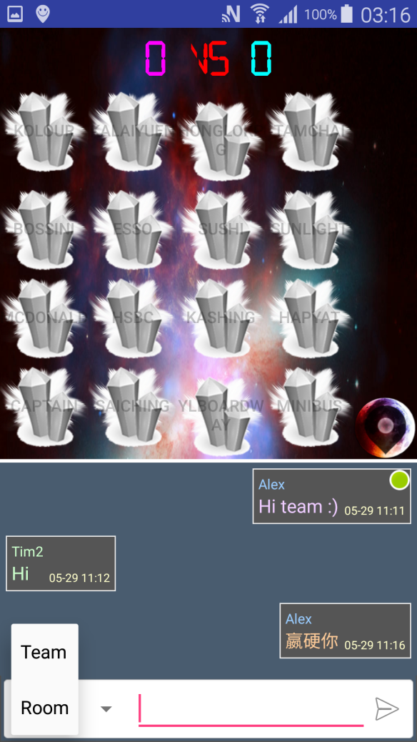Once the game start, the UI will change to crystallization activity. The score, Crystal Four, Chatroom, DialogMap button will be displayed. Game information will be continuously updated in terms of recoloring and transforming the crystals. When player gets closed to generator (17 meters), he or she can click the relative crystal to play the mini game for dominating the generator.

Figure Crystallization

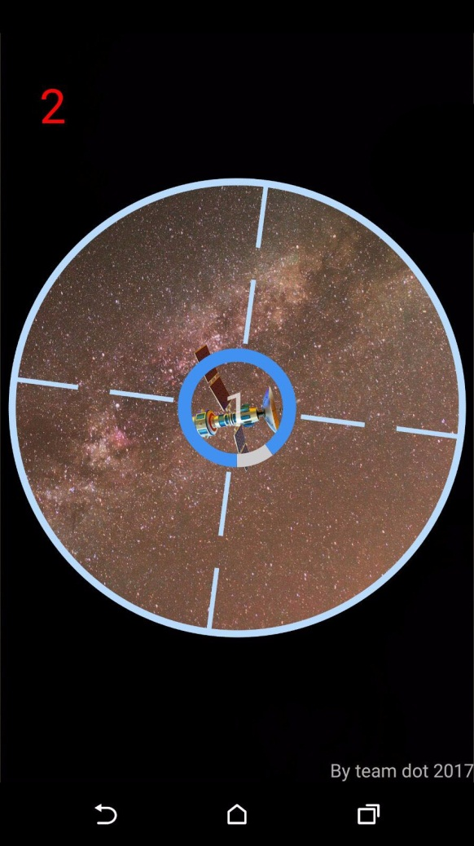

In the mini game, Satellite Hack, camera will be turned on with a sight (circle with a cross) at the center of the screen and user will see the screen turning red as well. Within a certain time, before the sight rotation stops, user has to turn their smart phone to point at a designated GPS satellite. When user is getting close to the target, the sight will become smaller. When it is getting close enough, a “Hack” button will show up so that user can click it to dominate the generator.

Figure SatelliteHack

* + 1. **Information flow**

There is four section of information flow, includes registration and login, enter game room to start the game, dominion in the game and finally ending the game.

Registration is simple, user send user data to database through register function. Login is similar by sending username and password, and it is verify by login function. The home function will send user id to GPS and it returns the region of user.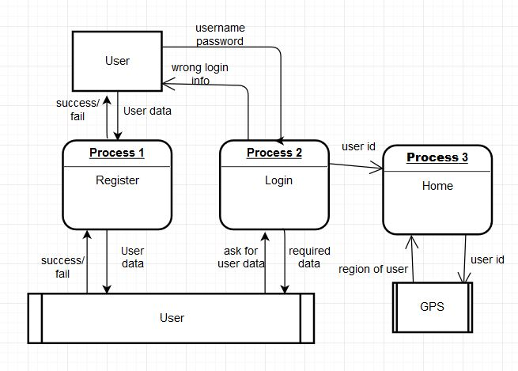

Figure Login Diagram

In entering the game room, the lobby will send a room list of that region to user. The user will send room id and user id if user wants to enter a specific room. If user wants to open a game room, he will send his own user id to open room function. Finally when the game ready to start, it will update status and start time to Room table.

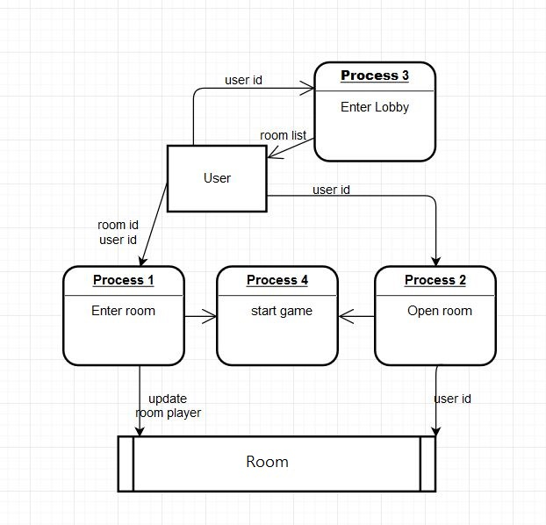 Figure Room Diagram

Inside the game, user will continue sending GPS and the check nearby Generator function will receive that GPS and check from the Generator table. If user is nearby a Generator, user can dominate it, if it is success, it will update a record in game dominion. Moreover, the server will continuously updating the score of each game.

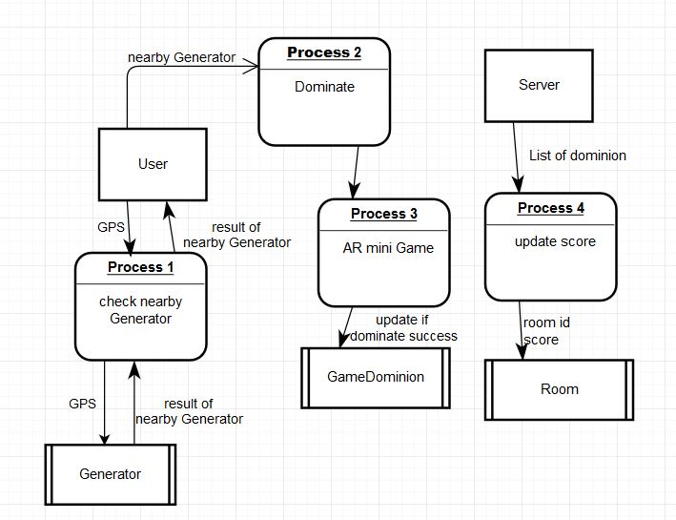 Figure Gaming Diagram1

Each dominate will also check is there any bridge (Connect-4) of the game, it will send user id to Game dominion table, and it will return a list of dominated generator by the team of user. When there is a team to bridge or time is up, server will send the room id to end game function for ending the game.

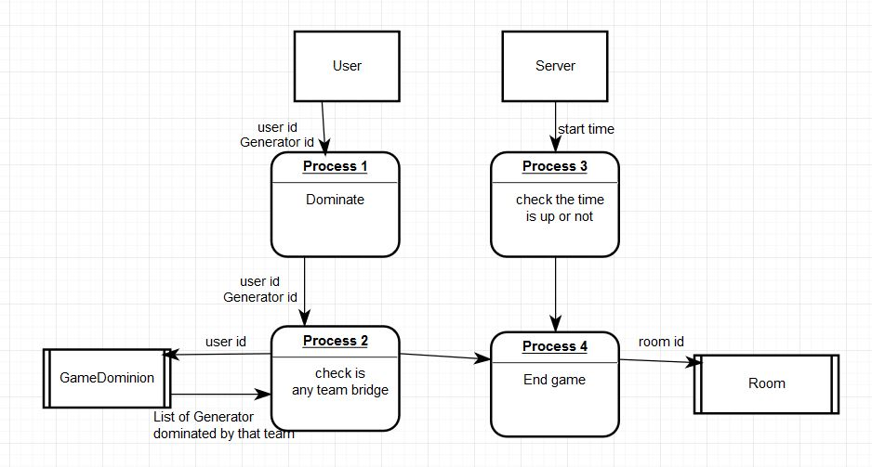

Figure GamingDiagram2

* + 1. **Modules**

There are web servers, users, game, Google map Android API, hardware and database modules.

Web server is used for processing the game Information between user and game like updating the score of game and send to user, also it will updating the database.

User can perform action through the web server. For example, user can open a new game room by sending its user id to server, and server will insert a new room in database and then return to user. User can also control the hardware device to use camera play mini game, walking in the real world to change the GPS of the phone.

The game is used for keep updating the location of a user by the GPS signal. And it will let user to start the Satellite Hack (mini game) when user arrive a specific location.

Google map Android API will provide a map for user to playing the game because user needs to walk to a place that has Generator.

Hardware is used for giving GPS to the game and using its camera to play the game.

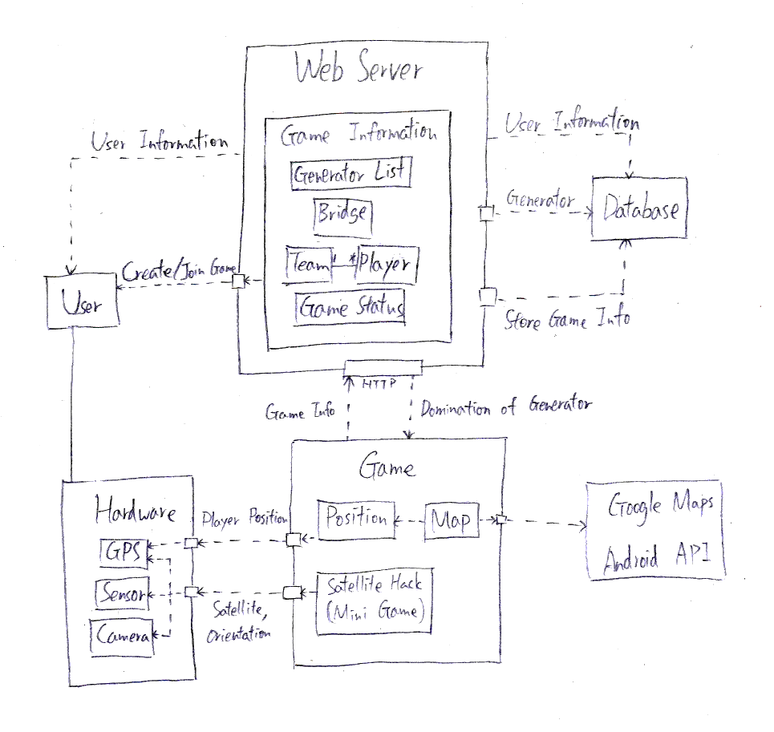Database is used to store all the user and game information.

Figure System Design

1. **System design and implementation**
   1. **The language development technology**

We have to handle a variety of situation as this project is a battle game. Methods and functions are written to cope with different needs like score counting, judgment and other logical parts, in Java. Besides, we are using MySQL database for storing the datasets such as user information, game information and the point’s coordinates. PHP is used as the server side language to perform server action. In order to increase the fun of gameplay, we are going to develop AR mini-game inserted within mainline.

The location based part would be one of the essential components, which is supported by the SDK – “Google Play Service”. It helps a lot in getting the coordinates divided into latitude and longitude from players. Google Map API will be applied into the user interface for coordinate performance.

With a view to drawing more users, we are considering to have integration with IM and social networking site like “Whatsapp” and “Facebook”. Maybe there a dialog box requesting the player to share their victory with the above applications

* 1. **The dataset**

First, there is a table that storing simple user information including user id, user name, password and the time of win of user.

Then, there is a Lobby table to store lobby information include the Lobby id and the corresponding region of that Lobby. Inside a lobby, there are some game rooms. So that there is a Room table to store room information includes room id, the create time of the game, which Lobby it is in, the status of game like waiting, running or finished. Also it will store the score of the two teams in that room. Furthermore, another table RoomPlayer will store the player in that room.

Inside the game, the player will keep trying to dominate the different Generator, so there is a GameDominion table to store that information. It has room id, the user id who dominated it, the Generator id, the time of dominate and the number of dominion of that generator in that game. Besides, there is a RegionGenerator table to store basic information of Generator like GeneratorID, the region of it, the map location of that Generator and finally the name of Generator.**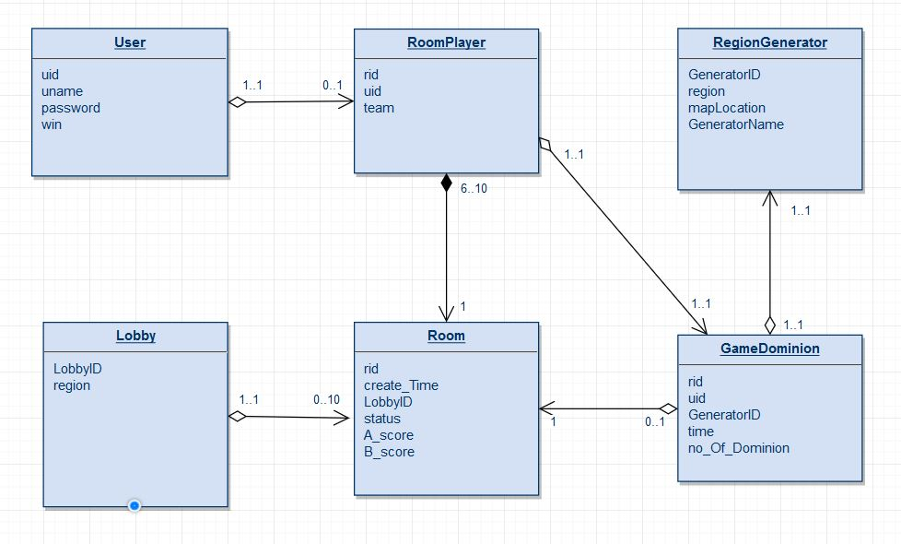**

Figure Dataset

# **Key Component**

## **Aim of Component**

The component is to design and construct Dominion of City. It will show the concept of design as well as the relative technologies.

The scene of crystallization generally consists of four parts - LBS, crystal four, map, chatroom, and satellitehack.

## **LBS (Location-Based Service)**

FusedLocationProvideAPI (FLPA) is the newest API which connects with GoogleApiClient for getting users location. The reason for choosing FLPA instead of traditional LocationManager is FLPA is more accurate and is faster to get the location by network assisting and location caching. Considering the inaccuracy of GPS and the shortest distance between generators, players located at 17 meters around the target is accepted.

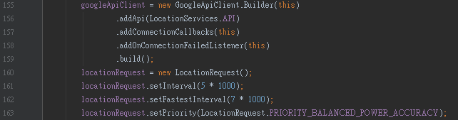

Figure Code of FLPA

## **Crystal-4**

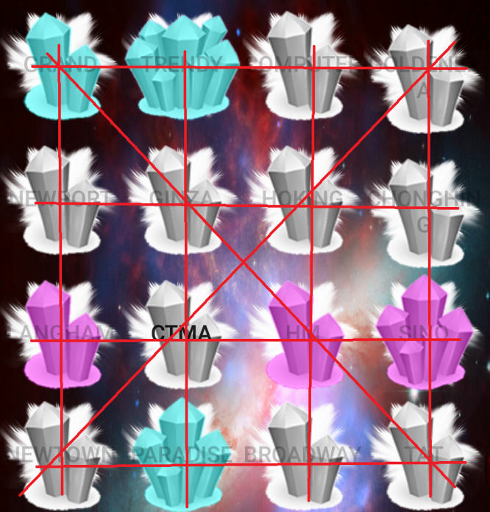The game logic is firstly inspired by the puzzle game called ‘Connect Four’ - the first to form four in a line will be the winner. As the locations we have chosen in reality are quite irregular distributed in the region, it is hard to tell the player which location they need to dominate. Randomly assigning the locations into a 4x4 crystal puzzle and utilizing the game logic of Connect Four make the gameplay easier to be understood. Players in a team can clearly develop strategies after the crystal puzzle is generated. Crystals will be recolored and transformed with the control of team and times of dominion.

Figure Crystal-4

The server will generate a random sequence of the generator in the beginning of a game in the database. The sequence and its relative information will be fetched and assigned into the Crystal-4. With the game goes on, the crystals will be recolored and transformed due to the change of information in the database.

## **DialogMap**

The DialogMap is inspired by another mobile game called ‘Pokemon Go’. As Crystal Four can only show the name of the target location, players may not familiar with the location themselves. It is unfair to the player who is new to the region.

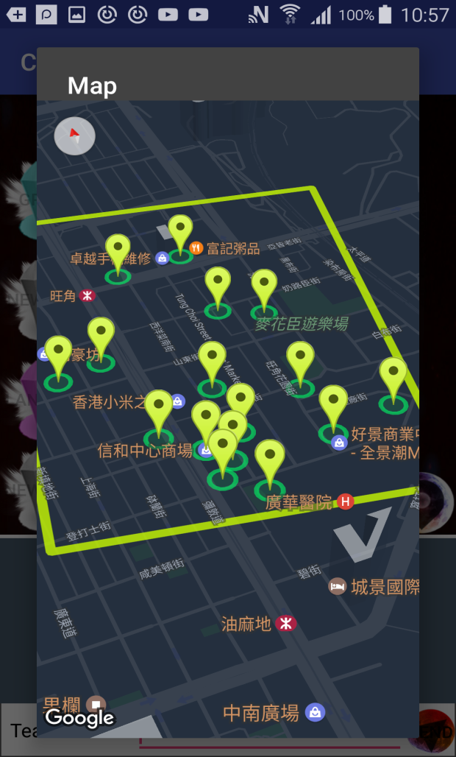In Pokemon Go, there is a map showing the target location and the current player’s location. It clearly tells the player where the target is located and what between.

DialogMap is a map shown in a dialog box. It indicates the generator's location and the rational range of approach.

It is convenient to use GoogleMapAPI to indicate the needed location on a map. By using the base of GoogleMap, every street and building are shown with their name as well as their details when pressed.

The rectangle line is set to indicate the suggested region just included all of the generators. Circles are drawn to show the rational range of approach. The little guy indicates the player's location.

Figure DialogMap

## C:\Users\user\Desktop\dot\Screenshot_2017-05-29-03-16-40.png**Chatroom**

The chatroom is provided for the communication between players. The player can set restriction to the players in the room or in the team can read the message. It helps the team for developing strategies and reporting their location in order to achieve teamwork.

Figure Chatroom

## C:\Users\dixon\AppData\Local\Microsoft\Windows\INetCache\Content.Word\Screenshot_2017-05-28-10-44-54.png**SatelliteHack**

This is part of the mini game—Satellite Hack. The system first uses SatelliteFinder(finder) which is an Asynctask which asks user to turn on GPS in order to get GPS satellite signal. The finder then calculate the satellites’ position (elevation and direction) and randomly select several of them to be the target. Afterwards, the system “listens” to the smartphone’s acceleration sensor and magnetic sensor which tells the 3-dimemsional angle of the phone’s top edge. It is calculated for the angle of the camera to tell whether the camera points at the satellite.

Figure SatelliteHack

To give player hint where the satellite is, the UI show it by 3 ways. First, it is told by the circular bar. The closer the satellite, the longer the blue bar. Second, the background also implies the accuracy. When the camera has pointed at the satellite, the background is filled with galaxy view. Otherwise, it is showing the image in front of the camera. The last hint is the sound effect. When getting close to the satellite, a Morse code signal is getting louder. When getting far away, it is covered by noise.

If the player has pointed the camera to the satellite, a satellite image is shown at the center of the screen and player can click on it to perform ‘hacking’. According to the level of generator, player needs to hack enough satellites to clear the stage.

# **Evaluation**

The project will be evaluated in user interface acceptance test.

We invite 3 youth aging from 18 to 25, mainly pre-graduate, android-user try to use our application to without tutorial first. Then we will figure out that can they use the application normally without the tutorial. After they use the application, ask for the following question:

* Have you found difficulty using the user interface? Can you find and use the functions you want?
* Is the application efficient? Have you found any repeated or unnecessary process?

For the Login and Register part, they are satisfied with it. The user interface is straight forward to find the function they want to use. But they suggested to add an icon for player to be easily to distinguish different player.

Inside the Lobby, one of them thinks that it should add the room number to indicate the room more specifically.

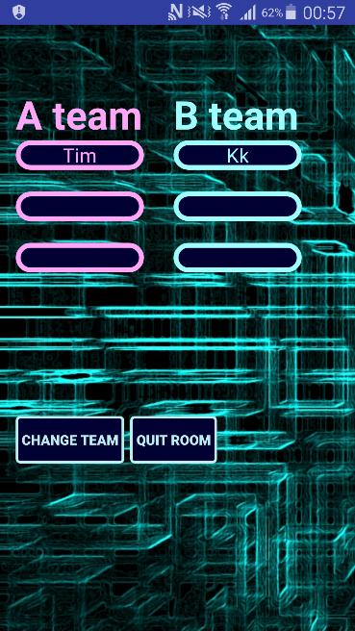Then inside the game room, he suggested some functions add to it. It includes adding the ready state for non-administrator player inside the game room. So that the administrator of the room needs to wait for all players set ready state before starting the game. Also, he suggested insert more attributes into room like Password and Room Name. If a password is set, the room will become private and only people who know the password can get in.

The player inside the room also can invite other player to join a specific game room. Inside the room, the player can change the team freely when one team is not full. It can perform by clicking a “change” button at UI. However, he recommends that performing it by clicking the player field of another team directly is more native.

Figure Room

Inside the game, one of them suggest that replace the regular crystal icon by a special icon that is related to the place of Generator. For example, if the Generator is place in a minibus station, the crystal can be replaced by a minibus icon. Besides, another player suggests that in the map of the game, it can be keep the player doll icon position in central of the map, when the player walks, the background of the map keep changing but the player doll icon is still at the center of the map. And for the chatroom inside the game, all of them can’t figure out the button to turn on/off the chatroom. Also, after a player dominate a generator, he wants to see the dominate record (text or picture) will show in the chat room to notify other players.

For the mini game satellite hack part, they think that it should has instruction first before the gameplay. The difficulty is enough for challenge.

Finally, since the memory leak problem is quite serious in the game, one of them thinks that the delay of game is severe and it must be improved. Moreover, it is proposed that the application can add some rankings to count the statistic of player and the game. For instance, the ranking of most win players, the highest score in game etc.

2. **Conclusion**

Reviewing the introduction part, most of the objectives and aims have been satisfied. We have developed a game that implements the location based service. When a player arrived a specific location, he or she can dominate that location in order to gain marks to win the game. During the dominion of location, players need to play a mini game on street and the mini game is the “satellite hack”. In this mini game, player need to pay attention and finding the satellite through their phones with movement of the smartphone. Moreover, we implement it as a multiplayer online game that user can choose to play a game freely with 1 to 3 persons per each team, it only requires the player number for each team is same. Last but not least, we also implement the “bridge” system which performs similarly with bingo, when one team connecting 4 Generators in a line, no matter horizontally, vertically or diagonally. The team successfully bridge the generator will have bonus mark and the game will directly end.

**Summary of Achievements**

Our solutions can provide a game with the combination of virtual world and the real world. Players need to changing their location of the game, he must make use of his foots and walk in the reality. Satellite hack is another component that merge the two things. Players using the camera inside the game to find the position of the virtual satellite in the mini game.

The bridge system is also an important element in our game. It makes the game seems to be a connect 4 game, but this time it is not as simple as dropping a disc, it is playing a mini game this time. This element may also affects the order of team to dominate a generator. The generator in the corner may become popular since it provide 3 ways to bridge.

We also provide a chatroom inside the game. Player can talk with two channels, one is for the team and another one is for the whole room. Therefore they can discuss about how to dominate the generators to gain a higher marks.

All of them are giving more difficulty about the game and let the player between a team to cooperate more in order to extending the social circle of players and give another idea about a smartphone game.

**Limitations**

Since the application requires larger memory, currently it need the device with higher configuration. Also, we found that only the device with Android 5.0 or higher can perform the application normally. The device with lower Android version like 4.1.2 cannot perform the dominate task well. After playing the mini game, it will directly return to Crystallization activity without dominate the generator.

The GPS is not very accurate since we have chosen balance mode for it. If using accuracy mode will increase the usage of battery, which is a more serious problem.

**Suggestion of future work**

1. Enhancing the game room. Player input a game room name and password (optional) to create a game room. Also, let the player to invite another to inside the game room. Adding a ready field for the game room administrator can start the game until all player has set ready on the ready field.
2. Addition feature in chatroom. First, after a player dominate a generator successfully, a record with the picture of map of generator will be shown in the chatroom. Second, a player can sharing the currently position to other players through the chatroom.
3. Adding simple instruction about the satellite hack mini game. Showing a simple video that demonstrating the gameplay of it.
4. Adding Statistic of players. Implement some ranking of players like the top 10 players with most win, the top 10 players with most played time, the top 10 highest score with the team member list.

# **Reference**

Barker, S. (25 Aug 2016). *Student play’Pokemon Go’ for physical, social benefits* Retrieved from <http://search.proquest.com.ezproxy.lib.ouhk.edu.hk/docview/1814002575?rfr_id=info%3Axri%2Fsid%3Aprimo>

Cranford, R. (25-31 Jul 2016). *‘Pokemon Go’ and Social Marketing* Retrieved from <http://search.proquest.com.ezproxy.lib.ouhk.edu.hk/docview/1810255881?OpenUrlRefId=info:xri/sid:primo&accountid=16720>

Xu, Hanzhang, Ying Xian, Haolin Xu, Li Liang, Adrian F. Hernandez, Tracy Y. Wang, and Eric D. Peterson. "Abstract 02: Does Pokemon Go Help Players Be More Active? An Evaluation of Pokemon Go and Physical Activity." *Circulation*. American Heart Association, Inc., 07 Mar. 2017. Web. 27 May 2017.

The Office of the Ombudsman, Hong Kong (2012) *主動調查報告 康樂及文化事務署 體育設施的預訂和使用*, Hong Kong: The Office of the Ombudsman.

Civic Exchange (24 Feb 2017). *香港市民平均擁有多少公共空間？思匯有數得計* Retrieved from <http://www.civic-exchange.org/materials/publicationmanagement/files/20170223PR_POSReport_tc_press%20release.pdf>

Teng, C. I., Huang, H. C., & Chen, J. L. (2015). Social Networking and Continuance Intention among Online Gamers. *臺大管理論叢*, *25*(2), 1-22.

Hsiao, C. C., & Chiou, J. S. (2012). The effects of a player’s network centrality on resource accessibility, game enjoyment, and continuance intention: A study on online gaming communities. *Electronic Commerce Research and Applications*, *11*(1), 75-84.

Snodgrass, J. G., Lacy, M. G., Dengah, H. F., & Fagan, J. (2011). Enhancing one life rather than living two: Playing MMOs with offline friends. *Computers in Human Behavior*, *27*(3), 1211-1222.

Wang, H., & Sun, C. T. (2011, September). Game reward systems: gaming experiences and social meanings. In *Proceedings of DiGRA 2011 Conference: Think Design Play*, 1-12.

# **Appendix A--Members’ Roles and Responsibilities**

* + Team Coordinator, Secretary: Dixon Wong
  + Database Expert: Tim Leung
  + GPS Expert: Toni Tang
  + System Analysis & Design: Dixon Wong, Tim Leung, Toni Tang
  + Programmer: Dixon Wong, Tim Leung, Toni Tang
  + Tester & Evaluator: Dixon Wong, Tim Leung, Toni Tang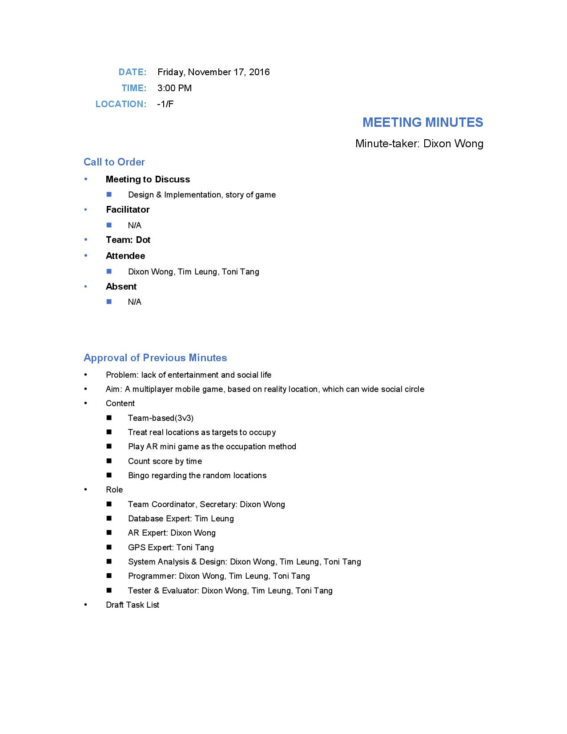**Appendix B--Meeting Minute**

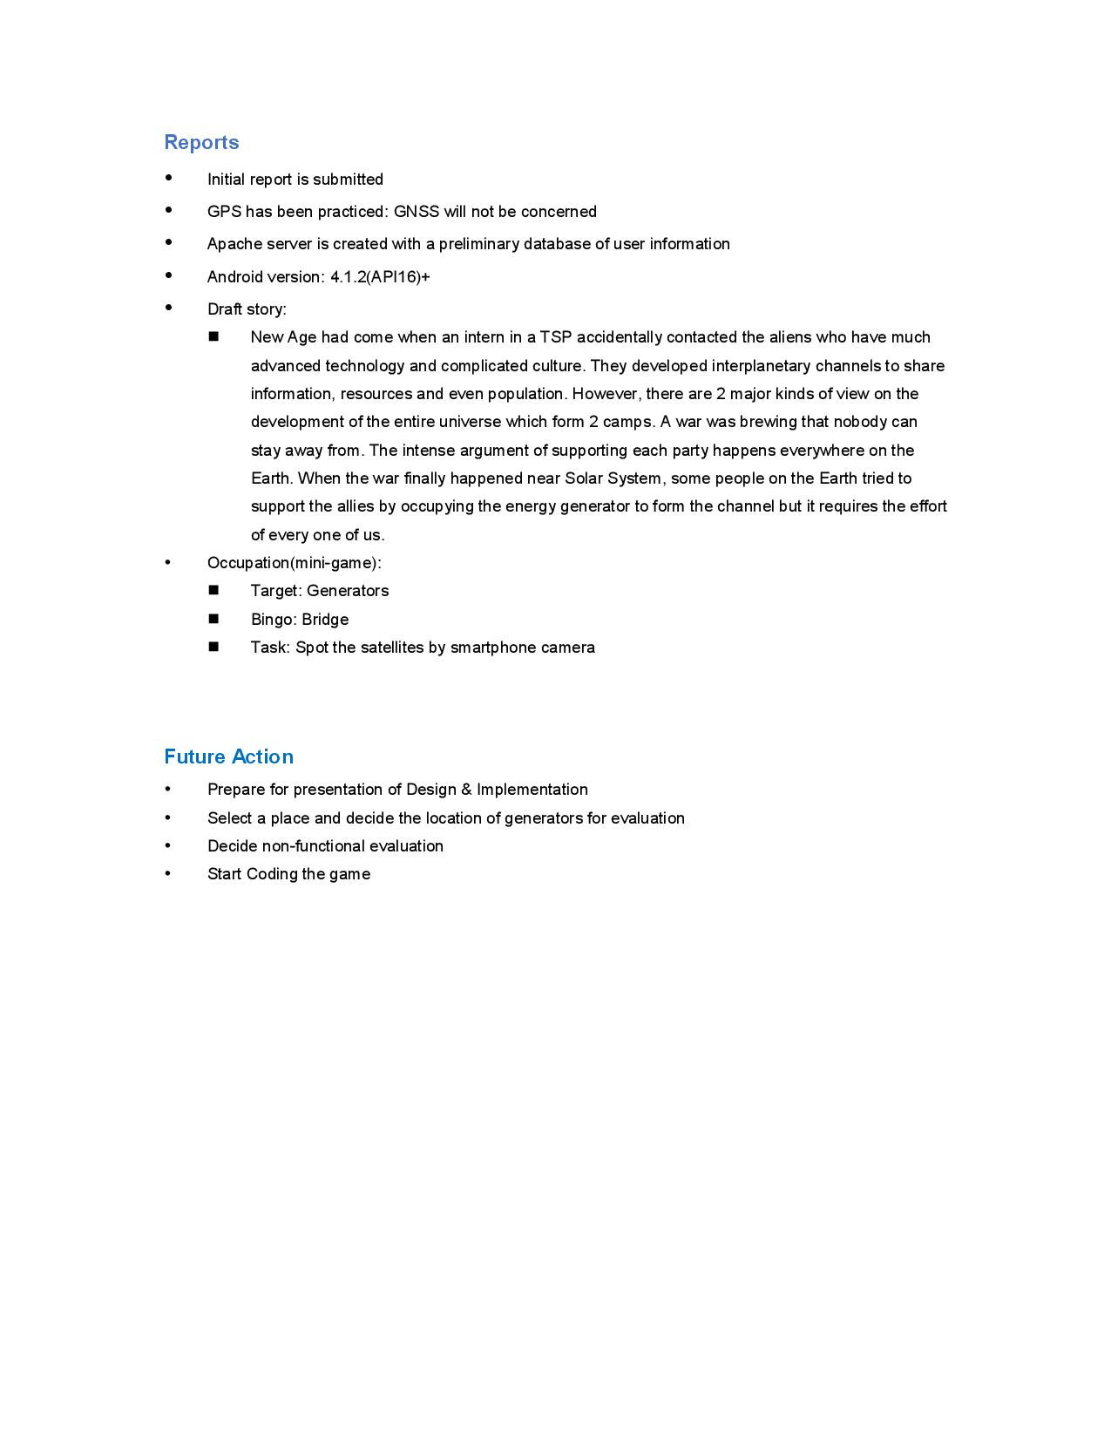

**Appendix C1: Team Member’s Final Report**

**Information**

Project Title: Dominion of City: Real Time Strategy Location-based Mobile Game

Student Name: Leung Man Him

OUID: 11182527

Project Team Name: dot

Supervisor: Li Tak Sing

**Declaration:**

I, Leung Man Him(OUID: 11182527), certify that the work is original and I have utilized guidance of our supervisor in completing this project, and that the content which is not our own has been attributed and referenced properly. There should be no copyrighted content without permission to use. There should be no confidential data.

Signature: \_\_\_\_\_\_\_\_\_\_\_\_\_\_\_

Date: \_\_\_\_\_\_\_\_\_\_\_\_\_\_\_

**Task Assigned to the Author and their status**

I am mainly responsible for the information acquisition between the android application and database. I have already built a database to store the information within the game, which is mentioned in the previous part. Also, some tasks like inserting data to database after dominion and response to the application are finished. Later I will work on the action between database and application after the game is ended. Moreover, I will building a user account system with Dixon later.

The following table outlines the task assigned t me in this project.

|  |  |  |  |  |
| --- | --- | --- | --- | --- |
| Tasks | Responsible Members | Target Date | Completion | Remarks |
| Game Information Acquisition | Toni and Tim | Jan 2017 | 100% |  |
| Server: Domination Status | Tim | Dec 2016 | 100% |  |
| Application: Domination Status | Tim | Dec 2016 | 100% |  |
| Server: Score Acquisition | Tim | Dec 2016 | 100% |  |
| Application: Score Acquisition | Tim | Dec 2016 | 100% |  |
| Server: Game Over | Tim | Jan 2017 | 100% |  |
| Application: Game Over | Tim | Jan 2016 | 100% |  |
| Dominate Generator | Tim | Dec 2016 | 100% |  |
| Server Setup | Tim | Nov 2016 | 100% |  |
| Server: Score Counting | Tim | Dec 2016 | 100% | Discussed in the followed short essay |
| Game Judgement | Tim | Jan 2017 | 100% |  |
| User Account | Dixon and Tim | Apr 2017 | 100% |  |
| Server: Account and User Data Management | Dixon and Tim | Apr 2017 | 100% |  |

**Review and Appraisal of Code Section**

**Part of Lobby.java**

public class GetGameRoomTask extends AsyncTask<String, String, List<RoomModel>> {

Context context;

GetGameRoomTask(Context ctx) { context = ctx; }

@Override

protected List<RoomModel> doInBackground(String... params) {

BufferedReader reader = null;

HttpURLConnection connection = null;

try {

URL url = new URL(params[0]);

connection = (HttpURLConnection) url.openConnection();

connection.connect();

InputStream stream = connection.getInputStream();

reader = new BufferedReader(new InputStreamReader(stream));

StringBuffer buffer = new StringBuffer();

String line = "";

while ((line = reader.readLine()) != null) { buffer.append(line); }

JSONArray parentArray = new JSONArray(buffer.toString());

List<RoomModel> roomModelList = new ArrayList<RoomModel>();

for (int i = 0; i < parentArray.length(); i++) {

JSONObject finalObject = parentArray.getJSONObject(i);

RoomModel roomModel = new RoomModel();

roomModel.setRid(finalObject.getString("rid"));

List<String> playerListA = new ArrayList<String>();

List<String> playerListB = new ArrayList<String>();

for(int j=0;j<6;j++) {

if (finalObject.has(Integer.toString(j))) {

JSONObject playerObject = finalObject.getJSONObject(Integer.toString(j));

if(playerObject.getString("team").equals("A")) {

playerListA.add(playerObject.getString("uname"));

}else if(playerObject.getString("team").equals("B")) {

playerListB.add(playerObject.getString("uname"));

}

}

}

roomModel.setPlayerA(playerListA);

roomModel.setPlayerB(playerListB);

roomModelList.add(roomModel);

}

return roomModelList;

}

return null;

}

@Override

protected void onPostExecute(List<RoomModel> result) {

super.onPostExecute(result);

RoomAdapter adapter = new RoomAdapter(getApplicationContext(), R.layout.row, result);

lvRooms.setAdapter(adapter);

}

}

**Design and operation of the code:**

This part of code is used to get the list of game room from server. It will extend an AsyncTask and create a http connection to get the list of game room. The list of game room will return as a JSON array. Finally create a list to store all room model in the JSON array and pass it to display in the User Interface.

In AsycnTask, it provides different methods. In the doInBackground method, I use it to collect the room list from the server. It will make a connection and then use input stream to connect the JSON response. Then it will divide the JSON array into a number of room models, which has room id and the player list of two team in that room. Finally, it will return the list of model.

In the onPostExecute method, it will create a room adapter object for the list of model and the display it in UI by setting the adapter.

**Issues:**

Since this method need to request a list of information, I can’t use as simple as just echo a give a response from PHP. Therefore, I create a JSON object in PHP and return it to the application. I used some time in learning how to read the JSON array in application which the JSON array is passed from PHP.

Besides, creating object model can let the program simpler. In this program, after receiving the JSON data from PHP, I am trying to store each element in a room model and storing in a room model list finally. It will be easier to implement than directly displaying the room in UI from the JSON array.

**Short Essay on Problem Solving**

I selected the score counting task for discussion in this part which has already remarked in the task list.

**Problem of the task**

In this task, there are a couple of problems that need to be solved. First, where should the counting function be placed. Second, since it should be a repeating task, how to repeat it. Finally, how to perform the adding score task.

**Consideration to solve the problem**

The script that counting that score should be running 24 hours. Due to the first problem, there are some ways that I considered for the counting function to place. It includes the server side, running the counting script in PHP or as a Cron Job. Also, it can be running by the application. However, if it is running by the application, it is not a good programming logic because it is running in the client side. Moreover, when different client is doing the score counting in their own application at the same time, it is easily to have asynchronous score and it is a serious problem as score is the most important component in a game application. Besides, Cron Job only can run a script as fast as once per minute. If I use Cron Job to calculating function, score can only update once per minute in the application. It will decrease the excitability of player.

To repeat a task, it can be solved by create an infinite loop. Which is simply develop a while(true) loop, and then put the score counting function inside the loop. However, an infinite loop is difficult to control and terminate. Since it is non-stop running, the web hosting will terminate it automatically after a period of times. It can also be done by refreshing the web page automatically. It requires a browser to keep running for the web page.

The third thing that I need to consider is the counting score task. The score of each team will be added each second by how many generators they are dominating. So, finding the active room and then adding score from the dominate record is one of the solution.

**Solution**

Based on these considerations, I decide to run the counting score task in a PHP script in server and refresh it once a second by a header function. For the score counting task, I will first find all the generator dominion information which the game room is running currently and it has the biggest number of time of dominion (it means that the generator is currently dominated is related to this record). Then, based on each dominion record, finding the team of user that dominating it and adding score to it.

**Conclusion**

The counting score function running successfully in the server. It refreshes by the browser once a second. It requires a browser of a device to running the script, but it is easier to terminate and control. It may not be the best solution, but its cost is low as it is easy to operate and terminate at the browser.

**Self Appraisal of Contribution**

Our application mainly divided into 3 parts. The GPS setting of map, the satellite hack mini game and basic operation like register, create and joining the game room. I mainly responsible for the basic operation part. Although the difficulty is relatively low when compare with other parts, it also needs to work properly and confirm its functionality. At the same time, I am responsible to testing the part that I have developed.

For the presentation part, I have worked on preparation of the slides of mock presentation and the mock presentation delivery is done by me.

**Appendix C2: Team member’s Final Report**

|  |  |
| --- | --- |
| Supervisor: | Dr. TS Li |
| Team: | dot |
| Member: | WONG Tik San 11181021 |
| Programme: | Internet Technology (9717) |
| Date: | 28/5/2017 |

**Declaration:**

I, Wong Tik San(OUID: 11181021), certify that the work is original and I have utilized guidance of our supervisor in completing this project, and that the content which is not our own has been attributed and referenced properly. There should be no copyrighted content without permission to use. There should be no confidential data.

Signature: \_\_\_\_\_\_\_\_\_\_\_\_\_\_\_

Date: \_\_\_\_\_\_\_\_\_\_\_\_\_\_\_

## **Task and their Status**

I am the Team Coordinator and Secretary who keep documents and hold meetings. In most meetings I lead the discussion and assigned work to the teammates. The followings are the tasks assigned to me.



In system development, I took care of the design and implementation of the mini game and chat-room. Afterwards, I gathered the work of my fellows for integration and focus on testing the entire system. All works are done exception task lists.

1. **Review and Appraisal of Code Section**

private class StartGame extends AsyncTask<Void, Void, Void>{  
  
 @Override  
 protected Void doInBackground(Void... voids) {  
 if (game.getState().compareTo(State.*ACTIVE*) >= 0)  
 throw new State.StateException("Game has been started.");  
 Log.*i*(*GAME\_TAG*, "Wait til satellites are ready.");  
 while (!finder.isDone()) {  
 try {  
 Thread.*sleep*(1000);  
 } catch (InterruptedException ignored) {}  
 }  
 slaut.start();  
 game.setState(State.*ACTIVE*);  
 Log.*i*(*GAME\_TAG*, "Start Satellite Hack.");  
 return null;  
 }  
……

public void hack(View view) {  
 new AsyncTask<Void, Integer, Void>() {  
  
 @Override  
 protected void onPreExecute() {  
 satellite.setEnabled(false);  
 }  
  
 @Override  
 protected Void doInBackground(Void... aVoid) {  
 if (game.getState().equals(State.*READY*))  
 throw new State.StateException("Game not started yet");  
 if (null == hackTarget)  
 throw new NoTargetException("No hacking target");  
 //try to remove target satellite  
 if (game.removeSatellite(hackTarget)) {  
 effect.hit();  
 int satelliteCount = game.countSatellite();  
 Log.*i*(*GAME\_TAG*, String.*format*(  
 "Satellite hack success. %d satellite(s)' left.", satelliteCount));  
 publishProgress(game.countSatellite());  
 if (satelliteCount == 0) {  
 Log.*i*(*GAME\_TAG*, "All satellites are hacked. Stage clear.");  
 gameOver(true);  
 }  
 hackTarget = null;  
 }  
 return null;  
 }  
  
 @Override  
 protected void onProgressUpdate(Integer... values) {  
 satelliteCountView.setText(String.*valueOf*(values[0]));  
 }  
 }.execute();  
 }

**Design & Operation**

This part of codes is the main part of the activity of Satellite Hack. First half is an Asynctask (inherited as StartGame class) for starting the game and latter is the ‘hack’ action.

StartGame is executed when the activity start. If the game is started already (reading game.getState()), the system will stop. If the SatelliteFinder (finder) has not fetched satellites, it will sleep for 1 second and check again.

When the system is ready, it will start the SensorListenerAndUpdateThread (slaut) which is a sensor listener as well as a thread. Slaut applies acceleration and magnetic sensor of the smartphone and calculate its orientation 3-dimemsionally. Then it updates the UI to give user hints for pointing the satellites. When user has pointer at the satellites, it shows a picture of satellite so user can ‘hack’ it.

When the picture is clicked, an Asynctask is run. After exception checked, it emits sound effect and vibration as success signal and it updates satellites state. When no satellites are left, it calls gameOver() to end this mini game.

**Problem & Mistake**

In Satellite Hack, there are several problem. First, this game consume a lot of memory in which Android assigns very limited resource to every application. Attaching a lot of image and animation, applying SurfaceView for displaying camera image, retrieving sensor data cause a severely demanding memory allocation. In the prototype, 2 gif image (loading and ending) cannot be shown. Besides, working with other parts of the entire system cause OOM exception before we flagged the app large-heap.

On the other hand, the UI is not clear enough that user may not understand their meaning without tutorial. For example, player may not know the satellite has to be clicked to hack. Those hints and the timer are not attractive as well.

**Problem Solving**

**Problem**

In the system design, we decided to add chatroom function. A chatroom should perform 3 major tasks, send outgoing messages, receive and display incoming messages.

Besides, the user may not want the chatroom to be turned on anytime so there should be a switch for chatroom.

When sending messages, user may also want to send to different people.

Messages should be received chronologically. Display of message should show the relation between user and the message. For example, when user is the sender of the message, it should be displayed differently from others.

A chatroom for smartphone should notify user when the activity is not on foreground.

**Consideration**

It would be an online chatroom so network connection is necessary. Android provide HttpUrlConnection which can send HTTP request and receive response. However, its weakness is the repetitive codes which is complex. In addition, it must not be used in UI thread which means I need to use Asynctask or thread.

The application has to tell the server identity. The best way is to use session then session ID should be stored and shared through the application. SharedPreferences is easy to use for purpose.

Due of the server design, messages will not ‘knock’ the smartphone to be received. The smartphone must ask server periodically. I should design a system that perform this repetitive task. The response should be formatted and contain sufficient information so JSON format is suitable. I need JSON parser like Jackson.

To notify user, there are several style of notification. InboxStyle is suitable.

It will be a component in Toni’s activity. I should make it easy to use without changing a lot of code.

**Solution**

First, I design ConnectionHandler class which handles the complicated code for HttpUrlConnection. It can send GET and POST request and return response. Besides, flagging it by useSession(), it can store and send session ID automatically using SharedPerferences. Then I write Messager class which handles 2 threads—Sender and Receiver, which can be switched and perform repetitive tasks. The former waits to send messages. The latter keeps asking server for any incoming messages in certain format of JSON and parsed by Jackson JSON parser. These class is reusable for most part of this application such as login, lobby can use them to retrieve data.

Meanwhile, I customized a Chatroom (subclass of Messager) which performs Messager function, updates the UI and notify user with notification. ChatroomView, MessageView are custom view which perform simple task like switching on or off the chatroom, decorating messages.

**Self-Appraisal of Contribution**

When writing the program, I wrote POJOs and assisting tools like ConnectionHandler for the whole team. I worked as a coordinator to hold meetings for discussion. I also created the Gihub repository to store codes and documents, also used for my later work for system integration. After integration, I test the application and find out most causes of the bugs and errors. In the system, I am responsible for Satellite Hack and chatroom. I also make meeting minutes and task list.

**Appendix C3: Team Member’s Final Report**

**Information**

Project Title: Dominion of City: Real Time Strategy Location-based Mobile Game

Student Name: Tang Chi Ho

OUID: 11145882

Project Team Name: dot

Supervisor: Li Tak Sing

**Declaration:**

I, Tang Chi Ho (OUID: 11145882), certify that the work is original and I have utilized guidance of our supervisor in completing this project, and that the content which is not our own has been attributed and referenced properly. There should be no copyrighted content without permission to use. There should be no confidential data.

Signature: \_\_\_\_\_\_\_\_\_\_\_\_\_\_\_

Date: \_\_\_\_\_\_\_\_\_\_\_\_\_\_\_

**Task Assigned to the Author and their status**

I am the GPS Expert, mainly responsible for the location based section in the project. My work is including getting location from the player, DialogMap’s design and coding, partially coding for Crystallization, making the UI for Crystallization, partially coding for getting needed information from database for Crystaliization.

|  |  |  |  |
| --- | --- | --- | --- |
| **Tasks** | **Responsible** | **Target Date** | **Completion** |
| GPS Test | Toni | Oct-16 | 100% |
| Server: Generator Management | Toni | Dec-16 | 100% |
| Game Information Acquisition | Toni & Tim | Jan-17 | 100% |
| Application: Coordinate Acquisition | Toni | Dec-16 | 100% |
| Server: Generator Coordinate | Toni | Dec-16 | 100% |
| Graphics Design | Toni | Mar-17 | 100% |
| User interface | Toni | Feb-17 | 100% |

**Review and Appraisal of Code Section**

**Code 1: Crystalliztion.GetGenInfo**

|  |
| --- |
| public class GetGenInfo extends AsyncTask<String,Void,List<GenModel>> {  Context ctx; Activity act;  List<GenModel> GenModelList = new ArrayList<GenModel>();  GetGenInfo(Context ctx, Activity act) {this.ctx = ctx; this.act = act;}  @Override  protected List<GenModel> doInBackground(String... params) {  try {  URL url = new URL(params[0]);  ConnectionHandler conHan = new ConnectionHandler(url);  conHan.useSession(this.ctx);  String result = conHan.get();  ctx.getSharedPreferences("genInfo", Context.MODE\_PRIVATE)  .edit()  .putString("genInfoStr", result)  .apply();  JSONArray oriArray = new JSONArray(result);  for (int i = 0; i < oriArray.length(); i++) {  JSONObject finalObject = oriArray.getJSONObject(i);  GenModel genModel = new GenModel();  genModel.setGenName(finalObject.getString("GeneratorName"));  genModel.setLat(finalObject.getDouble("latitude"));  genModel.setLng(finalObject.getDouble("longitude"));  GenModelList.add(genModel);  }  return GenModelList;  } catch (Exception e) {e.printStackTrace();}  return null;  }  protected void onPostExecute(List<GenModel> result) {  super.onPostExecute(result);  genInfo = result;  genInfoReady = true;  }} |

**Code2: DialopMap.onCreate()**

|  |
| --- |
| SharedPreferences pref = this.getSharedPreferences(  "genInfo", MODE\_PRIVATE);  String genInfoStr = pref.getString("genInfoStr", "");  try {  JSONArray oriArray = new JSONArray(genInfoStr);  for (int i = 0; i < oriArray.length(); i++) {  JSONObject finalObject = oriArray.getJSONObject(i);  GenModel genModel = new GenModel();  genModel.setGenName(finalObject.getString("GeneratorName"));  genModel.setLat(finalObject.getDouble("latitude"));  genModel.setLng(finalObject.getDouble("longitude"));  GenModelList.add(genModel);  }  }catch (JSONException e){}  for (int i = 0; i < GenModelList.size(); i++){  genCoor[i] = new LatLng(GenModelList.get(i).getLat(), GenModelList.get(i).getLng());  } |

**Key Success and Failure**

The current obstacle for my work is that I lack of the technical knowledge for the server action, I am going concern the coordinates handling in the server side.

In developing the GPS part, there is fortunately many sources and tutorial video about making GPS. It give a big hand to me and I successfully completed the part of getting coordinates from device after installed the related tools and packages.

Graphics and UI are fined for me and they look smooth so far.